# Checklist for Flow of work

* Use **Wiring Checklist** to plan your wiring between sensor and Arduino. Draw the wires between VCC and GND wires and write the color of jumper wire you plan to use in the respective columns in the table. THIS CAN BE DIFFERENT FROM THE VIDEO! (This is not required if we are directly connecting the LED on the Arduino board
* Connect wires between Sensor and Arduino as per your Wiring Checklist
* Connect Arduino to PC and start EzVid Screen Capture, start recording and Arduino IDE
* Is the **correct Board** - Arduino Genuino/Uno selected in Menu Item as shown below?

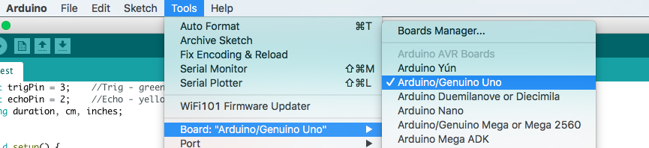

* **Is Correct port selected as shown below? THIS VARIES FROM PC TO PC, BUT ENDS WITH “ARDUINO/GENUINO UNO”**



* Verify and Upload Code
* **I see the LED blink (1 second on and 1 second off) and it is correct!!**

**______________________________________________________________________________________**

# Using the same example Code (aka sketch) to do more:

**1. To get LED to be on always**

**void loop() {**

**digitalWrite(LED_BUILTIN, HIGH); // turn the LED on (HIGH is the voltage level)**

**delay(1000); // wait for a second**

**digitalWrite(LED_BUILTIN, LOW); // turn the LED off by making the voltage LOW**

**delay(1000); // wait for a second**

**}**

**To get the LED to be on always, delete the 3 lines which are which are highlighted in the box.**

**2. To get the LED blink in a sequence**

**void loop() {**

**digitalWrite(LED_BUILTIN, HIGH); // turn the LED on (HIGH is the voltage level)**

**delay(1000); // wait for a second**

**digitalWrite(LED_BUILTIN, LOW); // turn the LED off by making the voltage LOW**

**delay(1000); // wait for a second**

**}**

**To get the LED blink in a sequence of (1 sec on, one sec off, 2 sec on, 2 sec off)**

**We need to copy paste the 4 lines highlighted in the above box like mentioned below. And to vary seconds of on and off, we need to change the delay from 1000 (1 Second) to 2000 (2 seconds) like below.**

**void loop() {**

**digitalWrite(LED_BUILTIN, HIGH); // turn the LED on (HIGH is the voltage level)**

**delay(1000); // wait for a second**

**digitalWrite(LED_BUILTIN, LOW); // turn the LED off by making the voltage LOW**

**delay(1000); // wait for a second**

**digitalWrite(LED_BUILTIN, HIGH); // turn the LED on (HIGH is the voltage level)**

**delay(2000); // wait for a second**

**digitalWrite(LED_BUILTIN, LOW); // turn the LED off by making the voltage LOW**

**delay(2000); // wait for a second**

**}**

# Troubleshooting

1. If the LED is not blinking
   1. You might have to use an 220 ohm resistor along with the LED